Concept of Change - Jacob’s Ladder B Format
B3: Generalizations
Generalizations are general statements that are almost always true. What generalizations can you make about change? Write two statements about change.  As you read, Love That Dog, what examples of change in the text fall under your generalizations? | Example:  Generalization: Change can be natural or man-made.  Text Example for Generalization: Jack’s point of view about poetry changed because of his teacher’s actions.
B2: Classifications
How would you categorize the details listed about change? Use a tree chart to group your words that are similar in some way into at least 3-5 categories. | 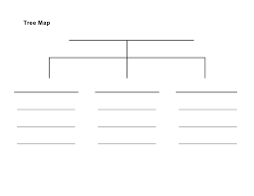
B1: Details
What words come to mind when you think of change? List different things that change around you (i.e. weather), within you (i.e. age), in your community (i.e teachers), in your country (i.e presidents), and around the world (i.e. currency). Use a bubble chart to brainstorm at least 10 -15 things you know about change.

