OPPORTUNITY TO HELP TONY: Tony has $34. Tony is going to the fair. The total cost for the fair can be represented by the function. C(x) = 2x + 5, where x is the number of rides Tony rides. Tony plans to ride 13 rides at the fair. Will Tony have enough money? If so, how much will he have left over? If not, how much more money will he need?

PROBLEM ANALYSIS STRIPS: Have students cut these boxes into strips and reassemble. Point out the sequence anchor words First, Then, Next, Last.

First,
We IDENTIFY the PARTS OF THE PROBLEM.
Tony has a TOTAL of $34.00.
Tony’s GOAL is to ride 13 rides.
The equation to FIND the TOTAL COST of the fair is:
C(x) = 2x + 5 and x = number of rides (13)
Then,
We SUBSTITUTE 13 for the letter x.
C(13) = 2(13) + 5

Next,
We SOLVE the EQUATION.
C(13) = (2*13) + 5
C(13)=(26) + 5
C(13) = 31
Finally,
We STATE the RESULT and CONNECT to the INITIAL QUESTION.
RESULT: Tony will pay $31.00
Tony has $34.00.
Tony will $3.00 left. (REMAINDER) ($34.00-$31.00=$3.00)
FINAL EVALUATION: Tony has ENOUGH money.

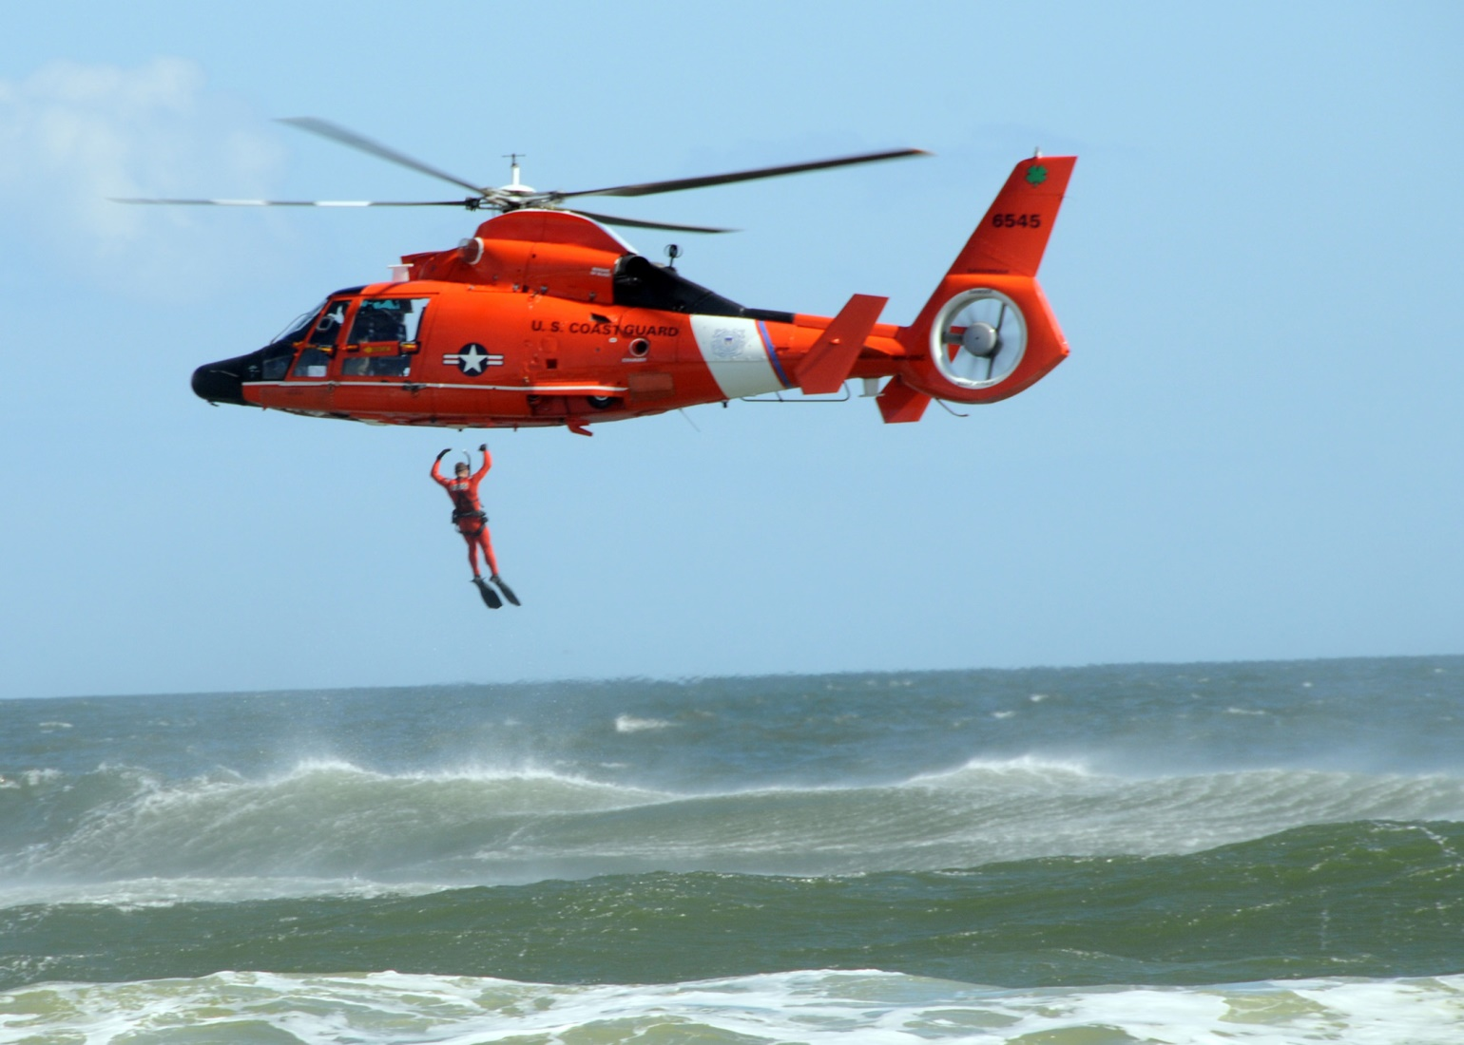

RESCUE STATION

- MATH PARTS | - WHAT DO I NEED TO DO? | - WHY?
Tony has a TOTAL of $34.00.  Tony’s GOAL is to ride 13 rides. | First, we IDENTIFY the PARTS OF THE PROBLEM.  The equation is to FIND the TOTAL COST of the fair to Tony. | This is to know what we have to work with.  This is to know if Tony’s goal is achievable.
C(x) = 2x + 5 and x = number of rides (13) | This is the equation to FIND the TOTAL COST of the fair. I will have to substitute. | When I substitute I can COMPARE the TOTAL with the COST. This is to see if Tony will have enough money to achieve his goal.
Next,  We SOLVE the EQUATION.  Finally,  We STATE the RESULT and CONNECT to the INITIAL QUESTION. | C(13) = (2*13) + 5  C(13)=(26) + 5  C(13) = 31  RESULT: Tony will pay $31.00  Tony has $34.00.  Tony will $3.00 left. (REMAINDER) ($34.00-$31.00=$3.00) | This is to decide if Tony will have enough money.  This is to decide if Tony will have enough money. The final result is that Tony will have enough money to enjoy himself.

- MATH PARTS | - WHAT DO I NEED TO DO? | - WHY?

My Math Journal

Name: _____________________________________

Topic: _____________________________________

Date: ______________________________________
Vocabulary: Verbal Operations Instruction Words:  Connect: Put together Identify: State Find: Look For Substitute: Replace Equation: Mathematical Sentence Solve: Calculate Result: Final Outcome Total: Everything Total Cost: Final Cost Achievable: We can do this! Initial: Beginning Multiply: Increase or Fast Addition Symbols: “*” or “x” Example: 2*2=4 or 2x1=2 Add: Increase. Symbol: “+” Example: 2+2=4 Subtract: Decrease. Symbol “-“ Example: 2-2=0 Divide: Decrease or Fast Subtraction Example: 2÷2=1 | STEPS:  First, you have to ________________________________________.  Then, you need to ________________________________________.  Next, you need to _________________________________________.  Finally, you will __________________________________________.  I need to work on ________________________________________because  ________________________________________________________  _______________________________________________________.  Special Notes:

